If we do a check-in option on the main screen and then when that is clicked we can do tabs for “Student” and “Staff”.

An example of tabs is below with the StartPoint, WayPoint and EndPoint, as you click on each tab it brings up the HTML for that tab on the same page. So just in the section where the pictures below are would be the location for the individual screens per tab selection (student, staff, etc).

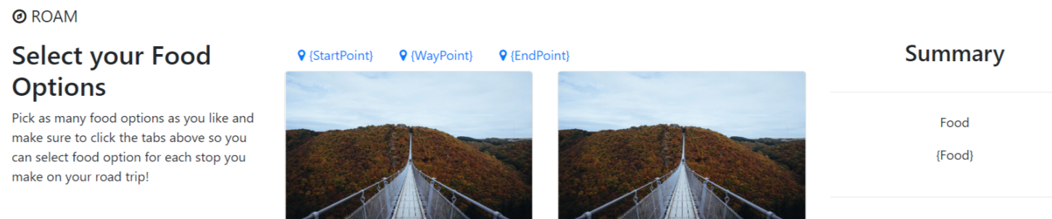

I was looking at the “Staff” information and I wanted to share with everyone what I am thinking could be a start at the logic and window.

|  |
| --- |
|  |

**Staff ID:**

**Enter the Staff ID and then use this to lookup other information in teacher or staff DB that will be populated/displayed on the screen (For example):**

|  |
| --- |
| 1. **Staff Name** 2. **Staff Photo** – we could use photos like Derek uses for his Slack to load DB? 3. **Staff Position** (teacher) 4. **Reunification Supervisor or Position in process?** – Room supervisor – is this teacher a reunification supervisor? 5. **Reunification Point** – Room number, holding room assignment, area assignment for the teacher. |

|  |  |  |  |  |
| --- | --- | --- | --- | --- |
| |  | | --- | | Received | | Transferred | | Released |   Staff Status | The Staff Status could be a dropdown encompassing 3 data types:   1. Staff Received or Checked-In (default) 2. Staff Transferred – if this is selected then another dropdown will pop-up on the window to denote the various types of student transfer methods. 3. Staff Released from GCPS |

|  |  |  |  |  |  |
| --- | --- | --- | --- | --- | --- |
| |  | | --- | | Counseling | | Medical | | Law Enforcement | | Other |   Transferred Status | The Staff Transfer could be a dropdown encompassing the following data types:   1. Counseling 2. Medical 3. Law Enforcement 4. Other – And an entry box where reassignment entry is allowed (like we did with GIPHY assignment)? |

|  |  |  |
| --- | --- | --- |
| |  | | --- | | SUBMIT UPDATE | | The SUBMIT button will post the relevant metric data to the DB such as date and time stamps (as the basic metrics are either counts or time lapses):   1. Status “Received”, then receive check-in date/time stamp. 2. Status “Released”, then released date/time stamp 3. Status “Transferred”, then transfer date/time stamp for each transfer method:    1. Counseling Transfer date/time stamp    2. Medical Transfer date/time stamp    3. Law Enforcement date/time stamp    4. Other – date/time stamp |